Enhancing Limited Dataset Analysis via Synthetic Data Generation Using the Synthetic Data Vault

Abstract
Limited DataSet Analysis is often used to examine and utilize a subset of data with certain identifiable fields trimmed down but may still contain necessary identifiers. In the CyberSecurity Domain, which we are interested in and is the area of interest of this paper, anomalies in the dataset are often present. Researchers might want to work on detecting anomalies to employ effective machine-learning models. However, this type of actual data may not be desirable or sufficient for these machine learning models, because of the privacy concerns of real people and the imbalance the data already contains. Therefore, there arises a need for a new subset of data that is more balanced and contains de-identifiable fields so that privacy is preserved. Synthetic Data Generation emulates the data and probability distribution. It creates entirely new data that mimics the characteristics of real data, often to fill gaps in data availability or simulate new scenarios. Thereby making it different from data augmentation processes which increase the diversity of an existing dataset by applying transformations to real data without changing its labels. This paper explores the production of new synthetic data using the Synthetic Data Vault (SDV). The goal of this paper is to conduct a comparative study while effectively generating a new set of synthetic data which in the cyber security domain, is more balanced especially with respect to the anomalies and normal distribution of the trace data, privacy coded and has the same data quality or performance attributes as the original data set.

1.Introduction
1.1 Importance of AI in the current Internet era

As the modern society evolves and new technologies emerge by the day, Artificial Intelligence has transformed the way humans interact with technology and consequently the world. With the advent of Artificial Intelligence, there is a massive increase in innovation across domains, aiding in improvements in various facets. The modern era of AI is pushing researchers to do new sciences and new kinds of discoveries and it enables powerful statistical tools that have advanced many areas of science by processing huge amounts of data and picking up patterns and trends that often go invisible to humans. AI is at the center of the current internet era, driving personalized online experiences, improved efficiency of search algorithms and enhanced security for a user-centric consumerism of the internet. For example, in e-commerce, AI pushes innovation through personalized shopping experiences, dynamic pricing, enhanced customer support. Internet of Things(IoT) combined with AI enhances connectivity and efficiency of devices and processing of data in real time. Social media, which constitutes 97 percent of all internet users[1], leverages AI to filter content, detect misinformation, ensuring users interact in a more protected environment. While it is difficult to predict the potential downside of AI, one possibility is the safety and privacy concerns of people when AI can be used to spy. And the possible leverage that big, powerful corporations may have over the large personal data. The escalation of automation of jobs due to AI might be a concern in the future. Governments may also need to step into the regulation of safety principles and use of AI.
Overall, AI has resulted in enhanced decision making and automation of tasks, personalized customer experience , risk management in financial decision-making.

1.2 Usability of AI to solve issues in various domains
AI has impacted every field of today’s world and some industries completely vanish without the help of AI. AI has enabled users and consumers to increase the personalisation experience. For example, Smart Assistants like Google Assistant, Siri, Alexa, etc use AI to cater to people’s personal needs and commands. Navigation systems everywhere have incorporated AI to enhance the comfort and convenience by showing real-time optimal plan of travel. Health Apps and wearable devices today, especially after the pandemic covid-19 hit the world, are all powered by AI to assess vital levels in real time and provide real-time information about the health and potential issues of an individual. Students have changed their approach towards education and use AI powered tutoring systems for personalized and optimal study experiences. AI in banking also increased the efficiency of fraud detections and personalized customer services . Military drones have AI-integrated smart systems to provide autonomous, enhanced intelligence, surveillance and reconnaissance. AI in cyber security helps massively by analyzing huge amounts of data, recognises patterns and anomalies and vulnerabilities to increase the security of networks and mitigating online threats and safeguarding sensitive data.These are just a few examples of specific task driven AIs in various domains of human life, but a General Purpose Artificial Intelligence which can do all sorts of tasks that a human can perceive with far less cost and greater scalability is expected to exceed human capabilities in almost every facet.

1.3 Advent of Deep Learning and GenAI
The advent of generative AI, exemplified by models such as ChatGPT (OpenAI, 2022) and DALL-E, has transformed how synthetic content is created. These large language models and generative adversarial networks can produce realistic text, images, and structured data, opening new possibilities for data augmentation in domains with limited datasets. In the context of this paper, generative AI techniques — specifically those implemented in the Synthetic Data Vault (SDV) library — are applied to generate synthetic tabular data that preserves the statistical properties of the original dataset.

Impressive is the ability to recognize and reason patterns in similar ways to the way humans do. AI now, is no longer a specialist which does specific tasks and is not able to generalize things very well.
Deep Learning has taken a major leap in recent times and it’s impact on the world is understated. Deep Learning powers most of the AI applications today and the advent of GenAI has meant there is an increase in productivity, efficiency and accuracy in those application over the years. Deep Learning has boosted many computer vision applications like Image Classification,Object Detection,Semantic Segmentation,Instance Segmentation,Facial Expression Recognition,Pose Estimation,Medical Imaging,Self-Driving Cars and many more. GenAI, which uses deep learning algorithms, has enabled research in areas like image generation,text generation used in creative industries, design, and virtual reality.
The growing popularity of generative AI is largely driven by its ability to respond to natural language prompts, making it accessible and versatile for various applications. As a result, its use cases have expanded across multiple industries, where AI tools are now commonly used to assist with tasks such as writing, research, coding, designing, and more.
The rise of generative AI has brought with it concerns related to ethics, potential misuse, and quality control. Since generative AI models are trained on existing data, including unreliable sources from the internet, they can produce content that is misleading, inaccurate, or entirely fabricated. Moreover, even when a source is cited, it may contain incorrect information or be inaccurately attributed.

1.4 Emergence of Big Data

Big data refers to vast and complex data sets that are large in size, diverse in nature, and challenging to store, analyze, and visualize for further processing or insights.At the heart of the big data revolution is the dramatic rise in data generation, with approximately 90 percent of global data being created in the past two years alone[[3]] This explosion in data is largely driven by a surge in online activity, the proliferation of social media platforms, and the widespread integration of Internet of Things (IoT) devices. Additionally, advancements in technology and the growing use of digital services across various sectors, from healthcare to retail, have contributed to the rapid accumulation of data, further emphasizing the need for sophisticated data management and analysis tools.

1.5 Shortage of Data in the Big Data World
In the realm of big data, it may seem paradoxical to discuss data shortages. Big data is characterized by huge amounts of data from a great variety of sources. But, this enormous amount of data is often characterized by low quality data storage and low relevance of the data. A new challenge presents itself in finding specific data which is required for driving meaningful insights, making data scarcity a significant concern in the big data world. High Quality data which is accurate, complete is useful for making reliable insights and decisions.

Data silos which refer to collections of data that are controlled by one department or group within an organization and are not readily accessible to other groups within the same organization, are another facet of Big data shortage which creates a perceived shortage of comprehensive datasets that can provide a holistic view of the business operations of the company or organization.Breaking down these silos often demands considerable time and resources, which further complicates the challenge.

A shortage of domain-specific data is still prevalent in today’s big data world. General, broader data is common but the data which is specific to a domain or field which meets the specific requirements of an organization is scarce and sometimes not assembled well. For example, healthcare or environmental areas of research require data which is precise and compliance with standards which is readily not available .
The cost associated with acquiring, storing and processing the big data can be high and reliable,accurate data can come for a premium cost and the infrastructure needed to manage and process large datasets can be prohibitively expensive, which can lead to data scarcity.

So shortage of data needs to be addressed by organizations carefully and by taking a multi-faceted approach by investing in data governance, enhancing data collection and integration methods, and utilizing advanced technologies like artificial intelligence and machine learning to improve data quality and accessibility.
.
[4]Analyzing big data using conventional data analytics tools is challenging because these tools often become less effective due to the five key characteristics of big data: high volume, low veracity, high velocity, high variety, and high value.

1.6 Our Problem Statement and Proposed Methodology
In this age, Data is priceless and the most important asset of any field. But the data available comes with a cost attached to it. In every field, there is a need for synthetic data generation which matches the quality and increases the quantity of the minority classes . More so, in the specific field of cybersecurity, finding complex datasets which are balanced and complete is difficult. That is where methods like synthetic data generation applied on a limited dataset give fruitful results for researchers to have a better quality dataset which can be applied to different use cases and can be used for testing hypothetical scenarios. This allows the newly generated synthethic dataset to be an improved, accurate, balanced dataset in terms of classes and variables and a confidential version of the original dataset. This ensures the dataset to be better in terms of both quantity and quality for research purposes. Our problem formulation revolves around given a dataset in cyber secutiy, is to explore different methods to generate synthetic data which closely matches the original dataset such as the distribution of classes and dependencies between them.Additionally, synthetic data should closely mirror the structure and format of the original data. This ensures that any analysis or processing applied to the original dataset can be similarly conducted on the synthetic version without compromising the accuracy of the results. Maintaining this fidelity between the two datasets is crucial for ensuring that insights drawn from the synthetic data remain valid and applicable to the real-world data.
In a time when making decisions for processing of data is crucial, analyzing small datasets has become an important field of study. In order to ensure data validity and quality, this study aims to investigate these issues and the methods used to address them. Synthetic Data Vault (SDV) is a library in python which employs a plethora of methods and modules to generate synthetic data based on the structure and the distribution of the original data.
Synthetic Data Vault offers different data synthesizers depending on the objective of the data synthesis. The synthesizers are listed below :
1)GaussianCopulaSynthesizer
2) CTGANSynthesizer
3)TVAESynthesizer
4)CopulaGANSynthesizer
5) Fast ML Preset
6) DayZSynthesizer
Note on DayZSynthesizer: The DayZSynthesizer is included in this list for completeness, as it is an officially documented synthesizer within the SDV library. However, it was intentionally excluded from the comparative analysis conducted in this paper for the following reasons:
1. Enterprise-Only Availability: DayZSynthesizer is not part of SDV's free Community package. It is an enterprise-licensed feature (denoted by '*' in the official SDV documentation at docs.sdv.dev/sdv), requiring a paid commercial license from DataCebo. As this study is academic in nature and conducted without access to an enterprise license, the synthesizer was not available for use.
2. Fundamentally Different Operational Paradigm: Unlike the other five synthesizers listed above, which learn statistical patterns and dependencies directly from real training data (using Gaussian Copulas, GANs, VAEs, etc.), DayZSynthesizer does not train a generative model on real data at all. Its name — 'Day Zero' — reflects this: it is designed to produce synthetic data from day zero, i.e., with little to no real data. It generates rows purely from metadata-defined parameters (such as column value ranges, categorical options, datetime bounds, and missing value proportions), optionally informed by a one-time parameter estimation step on real data via its create_parameters() function.
3. Incompatibility with Study Objectives: The core objective of this paper is to generate synthetic data that accurately replicates the statistical distribution, inter-feature dependencies, and class imbalance characteristics of the original DS2OS IoT traffic dataset. Because DayZSynthesizer does not learn from data distributions, it cannot reproduce the complex dependencies between features such as SourceType, DestinationServiceType, and the Normality label that are critical to the integrity of the synthetic dataset. Using it for this purpose would result in synthetic data that is structurally valid but statistically meaningless in the context of anomaly detection.
4. No Basis for Fair Comparison: Since all other synthesizers in this study (GaussianCopulaSynthesizer, CTGANSynthesizer, TVAESynthesizer, CopulaGANSynthesizer, and Fast ML Preset) are evaluated by training on real data and measuring how well the synthetic output mimics that data, including DayZSynthesizer in the comparison would be methodologically unfair and misleading — akin to comparing a generative model trained on a dataset against a random data generator seeded with column metadata.
In summary, DayZSynthesizer is a valid and useful tool for scenarios where real data is entirely unavailable (e.g., early-stage prototyping or schema testing), but it falls outside the scope of this study, which requires synthesizers capable of learning from and replicating real data distributions.

This Paper’s aim revolves around applying these different synthesizers on the cyber security dataset from kaggle. Firstly, the dataset worked on was taken from kaggle which is a DS2OS traffic trace data. It contains Internet of Things (IoT) traffic traces gathered in a DS2OS IoT environment. This trace data contains data which is gathered in the application layer and was captured using four simulated IoT sites with different types of services: light controller, thermometer, movement sensors, washing machines, batteries, thermostats, smart doors and smart phones.

The objective is to apply various data synthesizers to the original, highly imbalanced dataset, which contains a subset of underrepresented minority class data, in order to generate synthetic data that achieves a more balanced distribution between the majority and minority classes. The aim is to enhance the dataset's balance while preserving the original characteristics and structure. To assess the quality of the generated synthetic data, key performance metrics such as accuracy, precision, and recall have been calculated. A comparative analysis of the synthesizers' performance was then conducted to identify the most effective one for cybersecurity applications. This approach supports the use of synthetic data generation in cybersecurity research, particularly when dealing with imbalanced or limited datasets.

We can write here about, why Limited Datasets exist in this current Big data world-experimental data, expensive to collect more data, negative datasets are rare in occurrence or difficult to capture, etc.,

Limited Datasets are a subset of a Larger Dataset which consists of partial data and excludes restricted data or sensitive data.Limited Datasets are useful for maintaining privacy and sensitivity of the dataset in various fields, especially in Cyber Security, HealthCare and Research.

The Key characteristics of a Limited Dataset are :
- Absence of direct personal identifiers in the dataset, which can lead to privacy concerns of the classes of the dataset. Sensitive identifiers like Full Names, Social Security Numbers, Phone numbers are excluded in a Limited DataSet. However, identifiers which are not direct indicators of distinguishability like dates or locations are covered in the Limited Dataset which still enables meaningful research and analysis.
- Privacy Compliant. Limited Datasets ensures privacy of the dataset while still ensuring insightful analytics by complying to the many standards of certain security-ensuring regulatory bodies. For example, In Healthcare, datasets in the US are expected to be HIPAA (Health Insurance Portability and Accountability Act) compliant. Another example is the GDPR (General Data Protection Regulation) in the European Union ensures the privacy and security of data related to the people of the EU across the globe and imposes harsh penalties and actions against the organizations who do not comply.
- Research Friendly. Due to the nature of Limited Datasets, it is used extensively for research, analytics and audits where complete information is not required while still exploiting big data analytics without the need to compromise on privacy and security.

Contrary to what is expected in the Big Data world, Limited Datasets are actually quite prevalent accounting for a variety of reasons like :

- Privacy and Data Protection Regulations : Key research fields require data for meaningful explorations while still ensuring security and privacy of the datasets. Limited Datasets provide a great way to ensure that by the intrinsic nature of it to be legally compliant with regulatory bodies which ensure privacy, security and insurance of the data.
- Security: By limiting the data, organizations can better control who has access to the more sensitive parts of the data, reducing the risk of unauthorized use or exposure.
- Data Economy Principles : Organizations are encouraged to collect, process and retain only the data which is absolutely necessary, relevant for their respective analysis purposes and essential for the task in hand limiting data storage.
- Cost and Resource Burden : The collection and retainment of a limited dataset is quite expensive and difficult. The acquisition of large datasets is also hard which is a reason why limited datasets are so common. They pose a problem in careful handling of data to ensure that privacy regulations are adhered to and sensitive information is protected. For organizations, this means that there is increased operational costs, legal fees and costs for preventing misuse.
- Negative Datasets : There is a difficulty in searching for negative datasets which refer to the datasets where a particular feature or event is absent or discarded. These datasets are essential in machine learning for training classifiers to differentiate between instances that display certain features or behaviors and those that do not. Negative events are often less visible or go unrecorded, leading to incomplete or limited datasets.

2.Background
In this section, we provide an overview of the synthetic data generation architecture used. There is a brief overview of the dataset first, a run-through of the steps and architecture followed and the synthetic data generation modules used. The quality metrics used for the comparative study is also briefly mentioned.

2.1 Dataset profile :
Firstly, the dataset worked on was taken from kaggle which is a DS2OS traffic trace data. It contains Internet of Things (IoT) traffic traces gathered in a DS2OS IoT environment. This trace data contains data which is gathered in the application layer and was captured using four simulated IoT sites with different types of services: light controller, thermometer, movement sensors, washing machines, batteries, thermostats, smart doors and smart phones.

The main dataset worked on is the “mainSimulationAccessTraces” csv file which contains the field names:
SourceID : An unique identifier for the source of the traffic trace
SourceAddress : The address of the source in the application layer of the IoT device used to capture the trace
SourceType : The type of the source such as the IoT device used.
SourceLocation : The location of the IoT device used with respect to the house premises
DestinationServiceAddress: The address of the destination in the application layer of the IoT device used to capture the trace
DestinationServiceType: The type of destination service
DestinationLocation: The location of the destination of the corresponding Source IoT device.
accessedNodeAddress: The address of the accessed node in the application layer.
accessedNodeType: The type of the accessed node
Operation: The type of the operation performed, either read or write or others.
Value : The value recorded.
Timestamp: The timestamp of when the traffic trace was recorded.
Normality: The target variable indicating the classification of each trace as either normal or one of six anomalous categories.

The shape of the dataset is 357952, 13 .

The dataset was selected to explore the potential of applying limited dataset analysis and synthetic data generation in cybersecurity. Specifically, its unbalanced distribution of anomalies made it an ideal choice for investigating ways to enhance the dataset's quality and performance.

2.2 Data processing pipeline

This section describes the architecture of the data processing pipeline followed to execute this comparative study. The framework involves mainly 4 steps : Data Preprocessing , Quality Processing, Synthetic Data Generation, Concatenation of Synthetic Data and Real Data , Quality Processing of the newly generated data. This is described in figure 1.

Figure- 1 : The pipeline architecture is described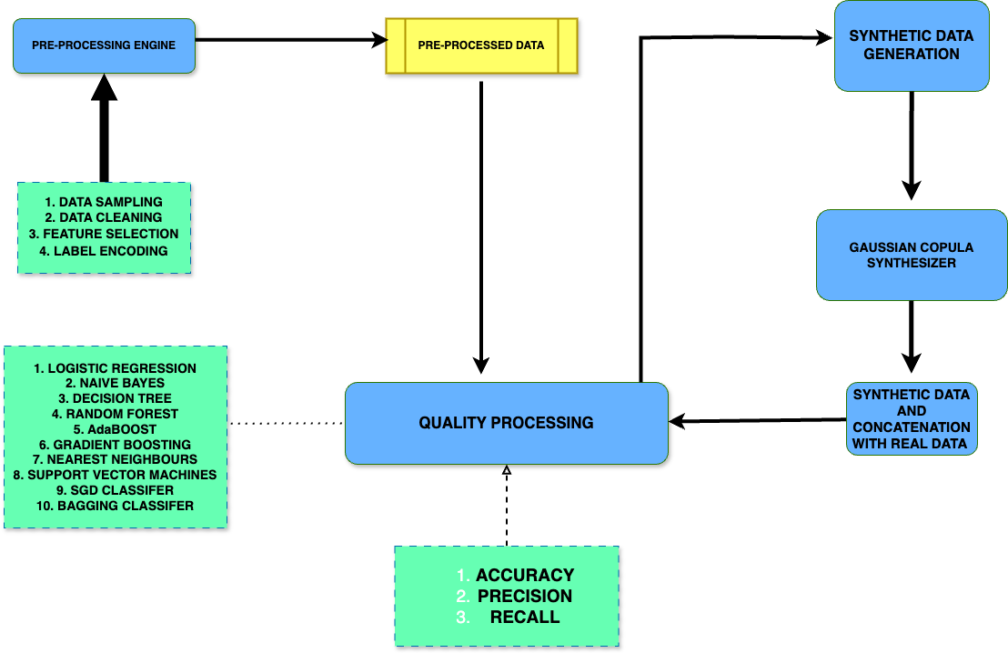

Figure 1

2.2.1 : Data Preprocessing
- Data Exploration and Subsetting: Begin by exploring the dataset to understand its structure. A sample of the data is taken to perform an initial exploration, focusing on identifying and handling missing values.
- Handling Missing Data: Any null or missing values are addressed by imputing them with the mode value of the respective feature.

2.2.2 : Imbalance Analysis of the Normality Feature

Class Distribution Assessment: Investigate the distribution of the ‘Normality’ column, which reveals a severe imbalance —97.30% of the data is classified as “normal,” while the remaining represents “anomalous” cases. This step identifies the need to address the limited representation of the anomalous class, crucial for improving model performance in anomaly detection tasks.

2.2.3 : Label Encoding

- Categorical to Numerical Conversion: The 'Normality' column consists of seven distinct classes. For compatibility with machine learning models, these classes are encoded into numerical values using LabelEncoder from the sklearn.preprocessing library.
2.2.4: Feature Selection

Correlation Matrix Analysis: After label encoding, a correlation matrix is generated. Features that exhibit high correlation values (close to 1) are considered redundant and are dropped to reduce multicollinearity. The correlation matrix is recalculated to validate the remaining features.

2.2.5. Model-based Feature Importance Evaluation
- Quality Attribute Assessment: Ten different machine learning algorithms are employed to assess the quality of the dataset’s features. These algorithms include:
  - Logistic Regression
  - Naive Bayes
  - Decision Tree
  - Random Forest
  - AdaBoost
  - Gradient Boosting
  - K-Nearest Neighbors
  - Support Vector Machine
  - Stochastic Gradient Descent (SGD) Classifier
  - Bagging Classifier
  - The dataset is split into training and test sets (80:20), and key performance metrics—accuracy, precision, and recall—are calculated for each model.

2.2.6. Data Concatenation for Simulation
- Training Data Concatenation: For simulation purposes, the X (features) and Y (labels) of the training data are concatenated into a single dataset. This combined data acts as the base dataset for generating synthetic data in the subsequent steps.

2.2.7. Synthetic Data Generation
- Generating Synthetic Samples: Using the Synthetic Data Vault (SDV) library in Python, 50,000 additional samples are generated from the existing 50,000 data points. This synthetic data generation focuses on creating balanced data by increasing the proportion of the underrepresented "anomalous" class while ignoring the overrepresented "normal" class. Multiple synthesizer approaches are used for this task, including the GaussianCopulaSynthesizer (a classical statistical method), CTGANSynthesizer and CopulaGANSynthesizer (GAN-based neural networks), and TVAESynthesizer (a variational autoencoder). These synthesizers aim to produce realistic synthetic samples that can augment the training data.

2.2.8. Quality Attribute Evaluation of Synthetic Data
- Comparison of Original and Synthetic Data: After generating the synthetic data, the same machine learning algorithms used earlier are applied to evaluate the quality attributes (accuracy, precision, and recall) of the synthetic dataset. These metrics are then compared to those of the original dataset to assess the efficacy of the synthetic data generation process and its impact on the overall data distribution.

Gaussian Copula is a distribution over the unit hypercube

3.Related Work
Limited dataset analysis has been a research topic primarily in the medical field over the recent years. And, Applying synthetic data generation to limited datasets has been of major interest over the past two decades particularly in the fields of healthcare, autonomous driving, finance, data mining, image generation and consumer market analysis.
Majority of Synthetic Data Generation is centered around Computer Vision although textual generation has steadily garnished popularity over the years mainly because of the cost effectiveness of synthetic data generation versus collecting real data and according to [Link], synthetic textual data generation is expected to have the highest growth among the various fields of synthetic data generation. [Goodfellow] has majorly contributed to this popularity of synthetic data generation by introducing Generative Adversarial Networks (GANs). They consist of two neural networks – Generator and Discriminator in which they are engaged in a minimax game where the generator generates data and discriminator evaluates its authenticity. Their ability to generate diverse datasets where real data or incomplete data is prevalent has made them invaluable to fields of computer vision, healthcare and drug discovery. Iqbal et [Link] discusses various text generation models in deep learning and states that Generative Adversarial Networks (GANs) dominate the field of continuous data, such as images, while Variational Autoencoders (VAEs) lead in the domain of discrete data, like text.

Dealing with Limited Datasets is a difficult task but still very plausible. Xiaopei Cai and Xueyang Tang Used the Siamese network (SN) to perform transfer learning along with few-shot learning to achieve satisfactory defect recognition accuracy of the high-speed railway slab despite the challenges of limited datasets.
Souza and Mouches et al. conducted an analysis of the effects of limited training data in distributed learning scenarios for brain age prediction. The study found that traditional model training (TM) consistently outperformed Federated Learning(FL) across all tested sample sizes. The analysis included scenarios with sample sizes ranging from 1 to 20 per site and evaluated training rounds of 20, 40, and 200. The results underscored that TM is more effective for small datasets, making it a preferable choice in scenarios where data is limited.

Li Xiong and Haoran Li et al. explore the capabilities of copula functions to model the dependencies among multiple variables allowing for synthesizing differentially private multi-dimensional data. Differentially Privacy is a mathematical framework that follows a standard that ensures the privacy of individuals in datasets when analyzing them. It allows organizations to extract useful insights from data while ensuring that individual records cannot be identified or inferred. The authors introduce the DPCopula framework, which generates high-dimensional, differentially private (DP) synthetic data by computing a DP copula function that captures the dependencies in high-dimensional datasets. This framework allows for direct sampling from the margins and the copula function, bypassing the need for post-processing required by existing histogram techniques, which can degrade accuracy or increase computational complexity. They present two methods for estimating parameters of the Gaussian copula function: DPCopula-MLE, which uses DP maximum likelihood estimation to compute correlations among dimensions, and DPCopula-Kendall, which employs Kendall’s τ for a rank-based correlation approach. However, the framework struggles with high dimensional data due to increased perturbation errors and computational complexity. The framework also cannot effectively handle attributes with small domains (fewer than 10 values), necessitating a hybrid approach that combines DPCopula with other methods for those attributes.

Figures
Diagram 1 : The value counts of the normality column of the original data

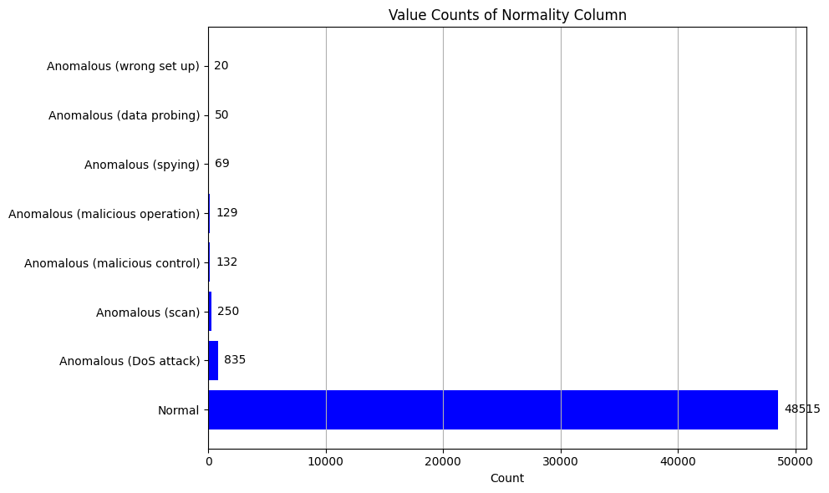

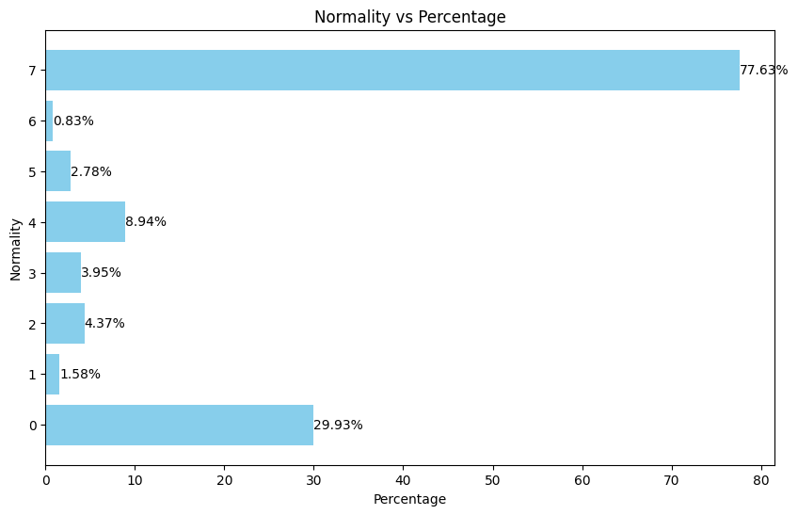
Diagram-2 : Percentage of the anomalous normality classes of the original data
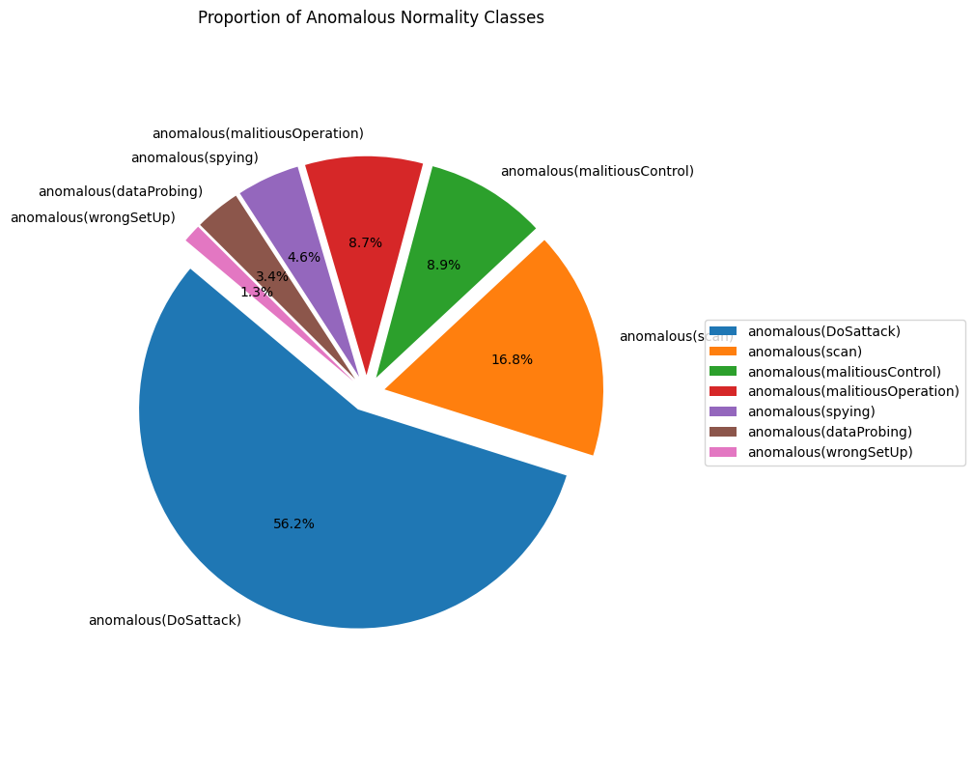

Diagram-3 : Bar chart of Percentage of the anomalous normality classes of the original data
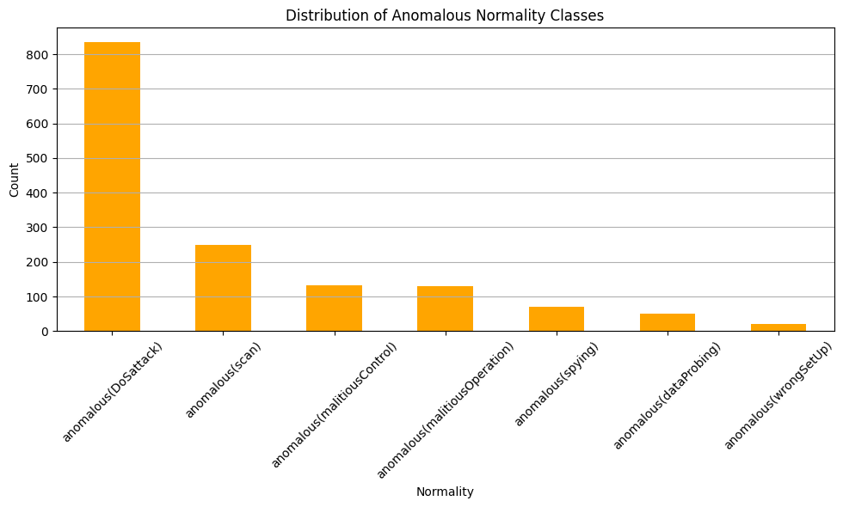

Diagram-4 : Pie chart of normality of the original data
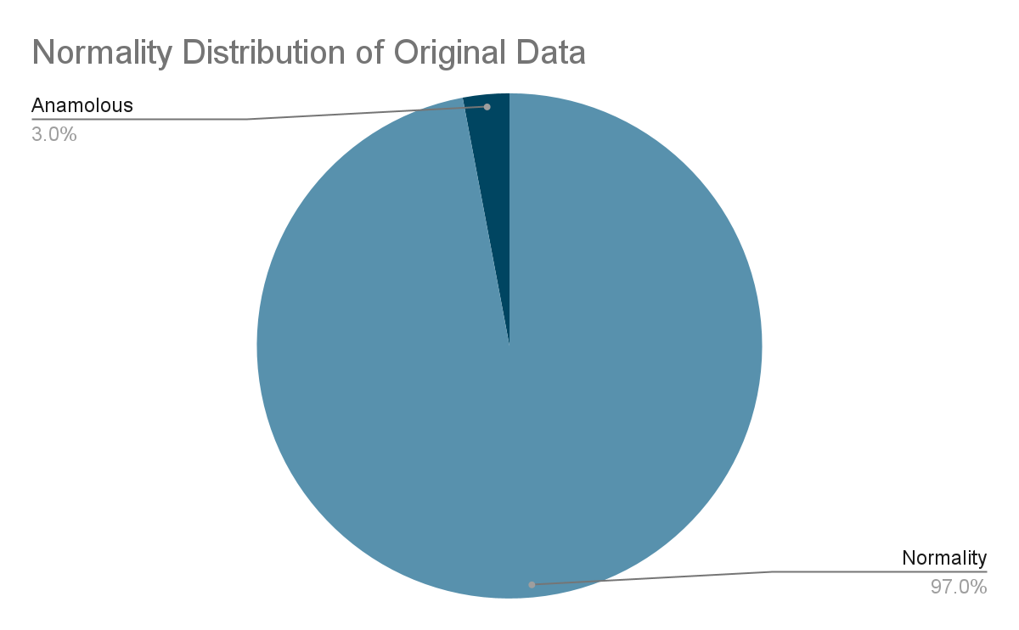

Diagram-5 :

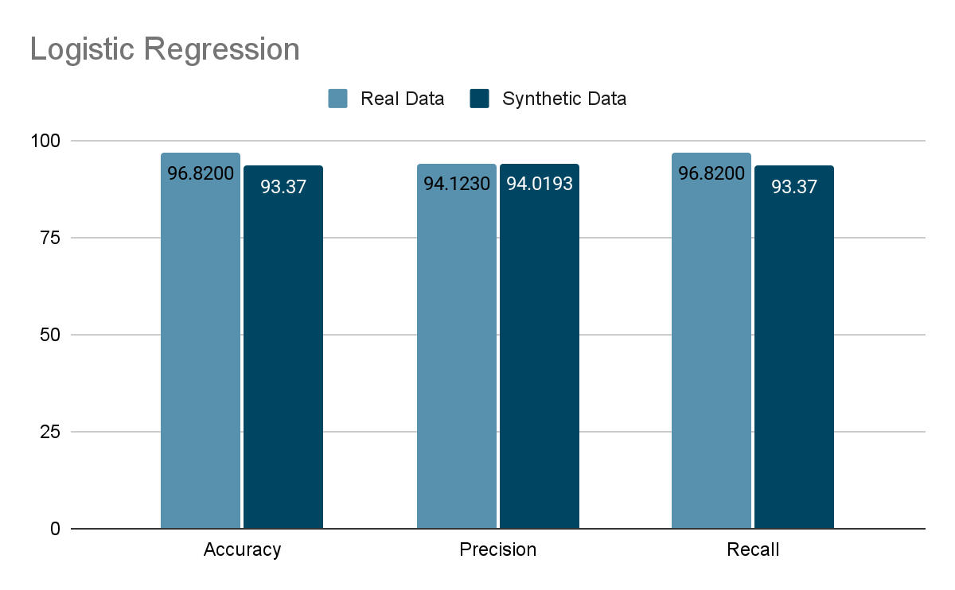
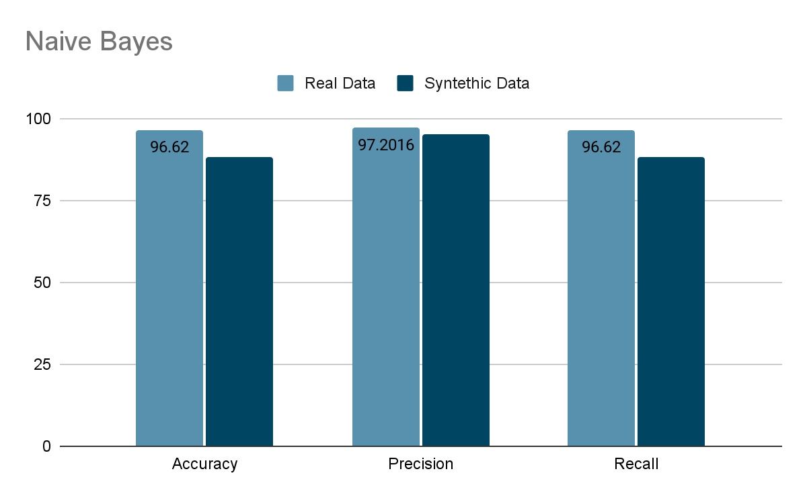

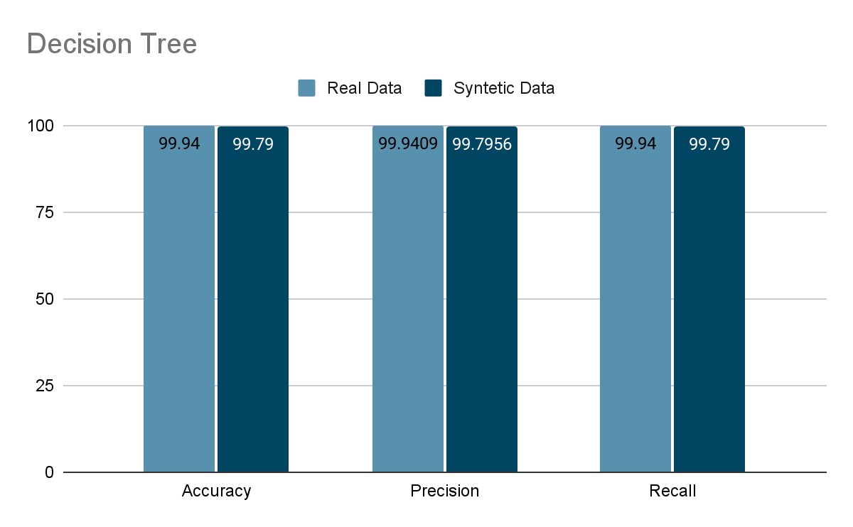
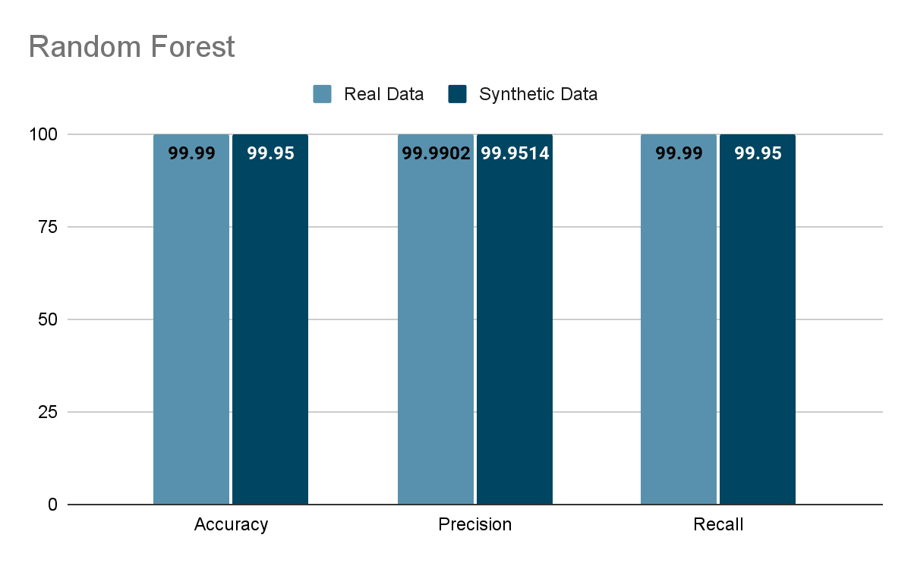
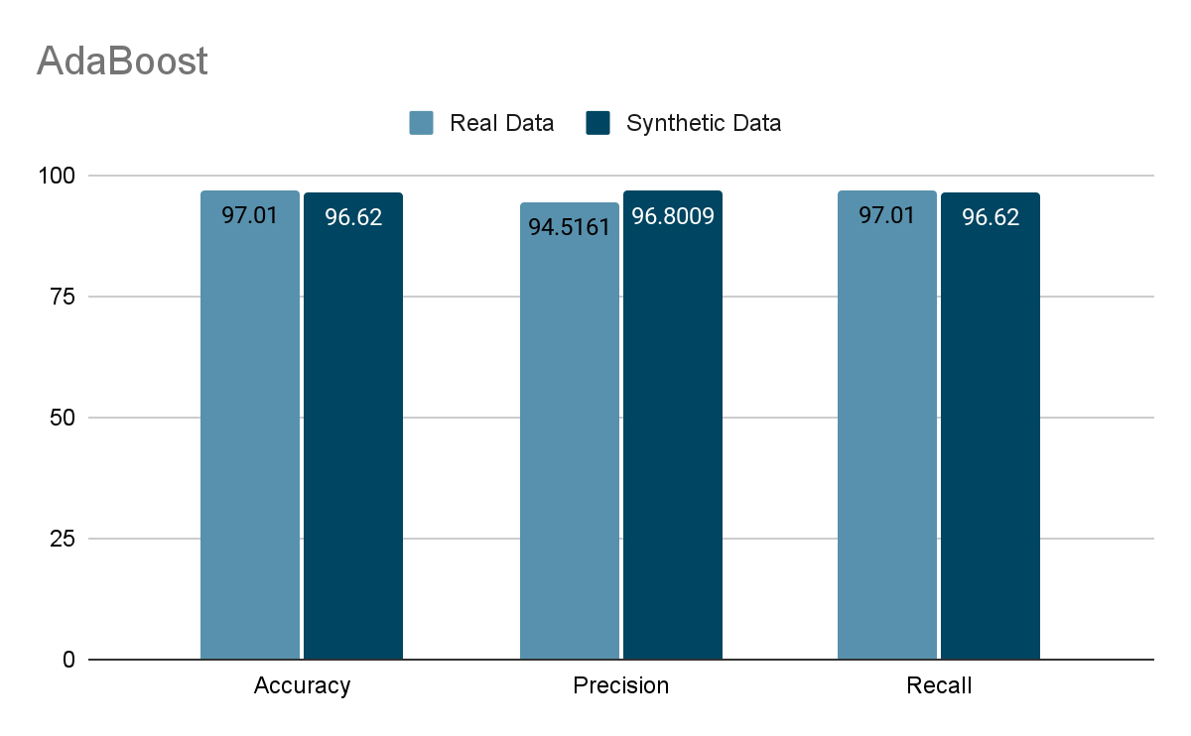

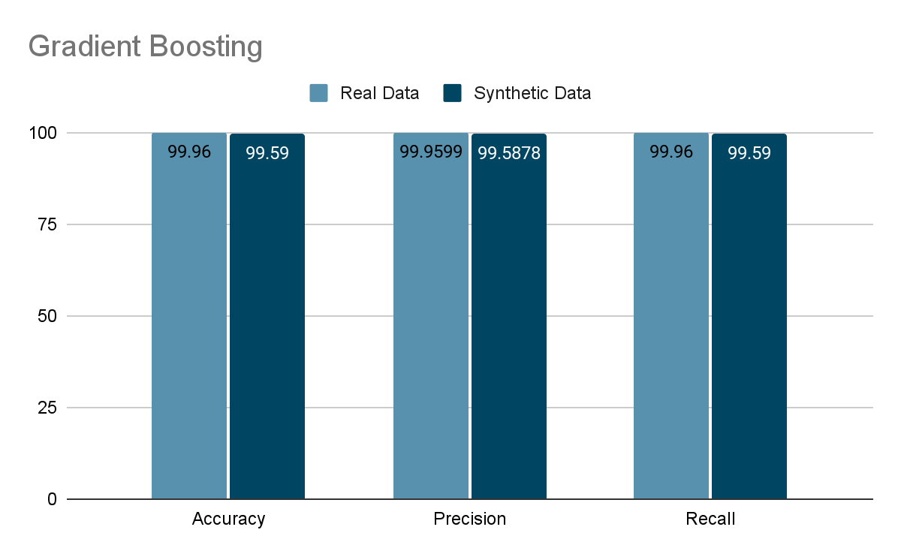

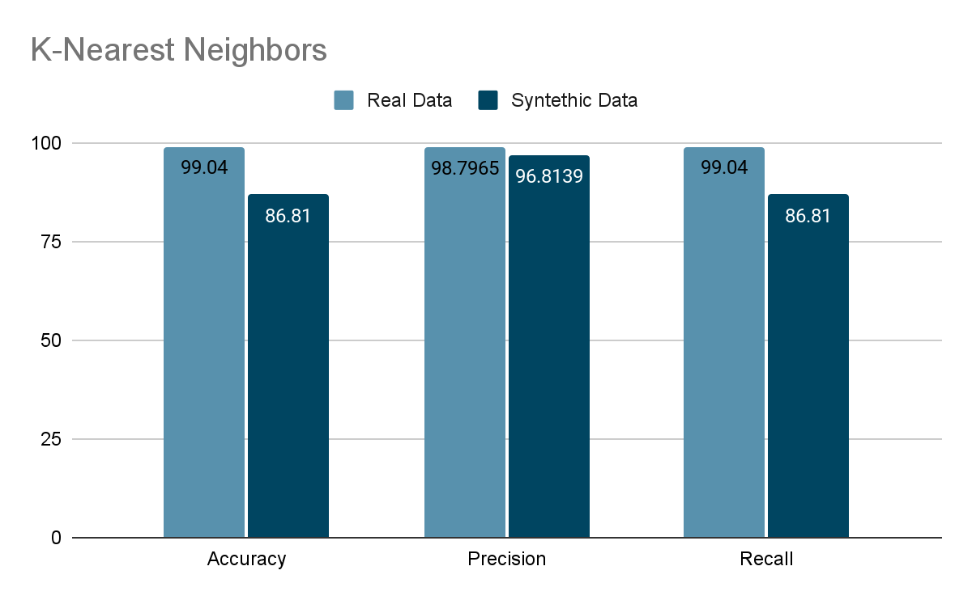

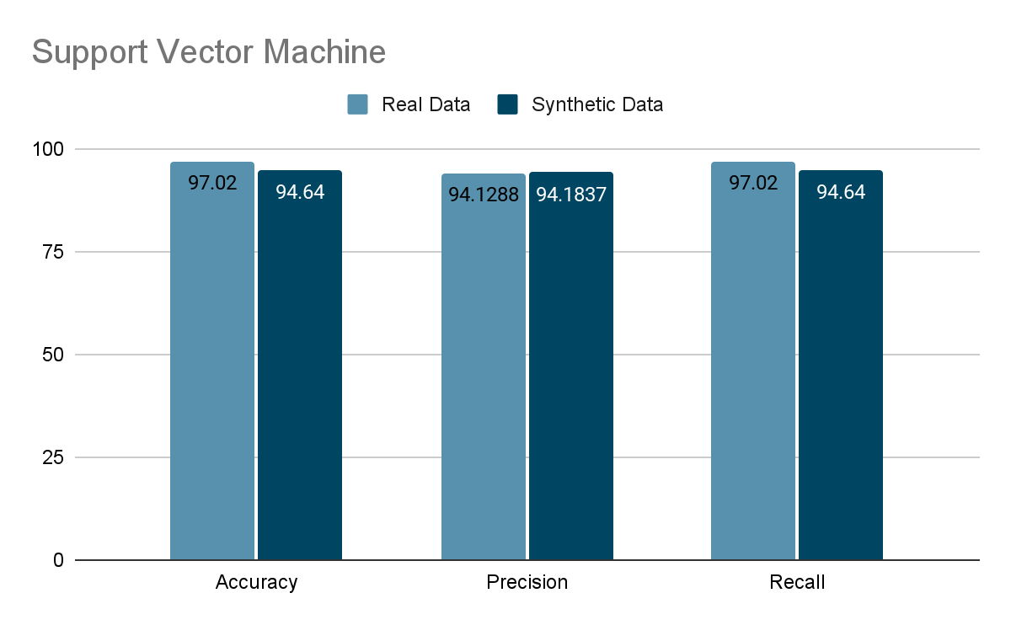

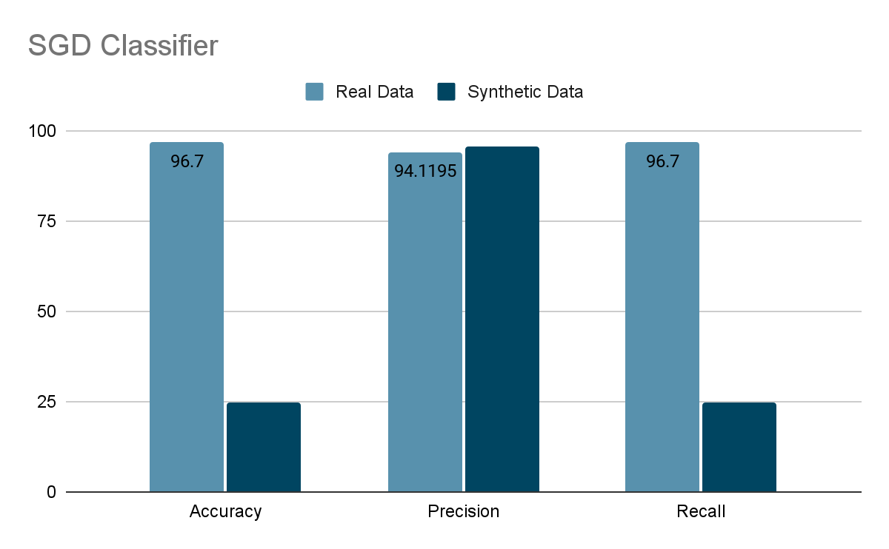

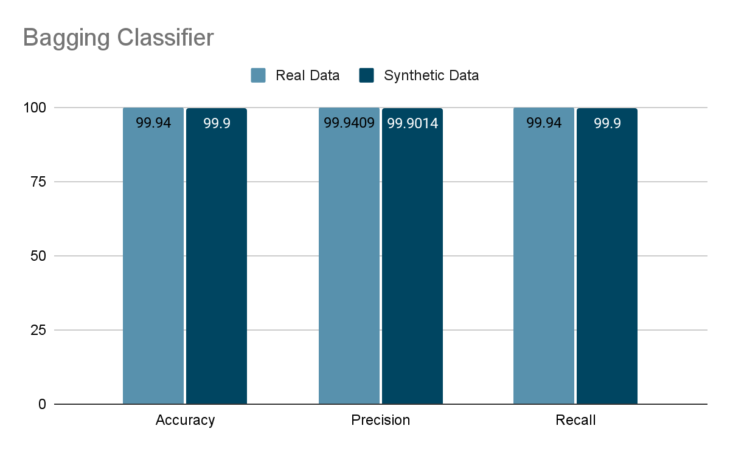
Normality percentages of newly generated synthetic data
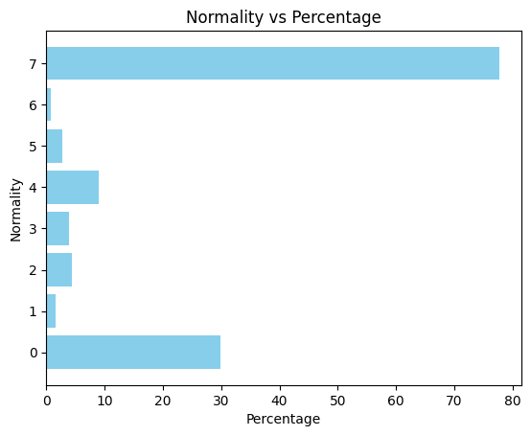

4. Results

Sampled Data : The initial data that is sampled of 50,000 instances has a very poor distribution of 97.03 percent of ‘normal’ values in the normality column. The correlation matrix of the sampled data says us that,

After naive concatenation of synthetic data (Approach 1), the combined dataset has 77.626 percent 'normal' values, reduced from 97.03%. While this is a shift toward balance, the dataset remains significantly imbalanced. As shown in Section 4.1, this naive concatenation approach actually degrades model performance. The more effective strategies — per-class synthesis with smart balancing (Approach 2) and limited data simulation (Approach 3) — are discussed in Sections 4.2 and 4.3.

This report analyzes the performance of various machine learning models when trained and tested on real data versus synthetic data generated using Gaussian Copula. The metrics used for comparison include accuracy, precision, and recall.

Models Evaluated
The following models were evaluated:
- Logistic Regression
- Naive Bayes
- Decision Tree
- Random Forest
- AdaBoost
- Gradient Boosting
- K-Nearest Neighbors
- Support Vector Machine
- SGD Classifier
- Bagging Classifier

Performance Metrics
- Accuracy: Proportion of correct predictions among the total number of predictions.
- Precision: Proportion of true positive results among the total predicted positives.
- Recall: Proportion of true positive results among the total actual positives.

4.1 Approach 1: Naive Concatenation of Synthetic Data
- Logistic Regression
  - Accuracy: Real = 0.9719, Synthetic = 0.5897
  - Precision: Real = 0.9446, Synthetic = 0.4500
  - Recall: Real = 0.9719, Synthetic = 0.5897
- Naive Bayes
  - Accuracy: Real = 0.9656, Synthetic = 0.6908
  - Precision: Real = 0.9762, Synthetic = 0.6328
  - Recall: Real = 0.9656, Synthetic = 0.6908
- Decision Tree
  - Accuracy: Real = 0.9994, Synthetic = 0.7642
  - Precision: Real = 0.9994, Synthetic = 0.7697
  - Recall: Real = 0.9994, Synthetic = 0.7642
- Random Forest
  - Accuracy: Real = 1.0000, Synthetic = 0.8357
  - Precision: Real = 1.0000, Synthetic = 0.8268
  - Recall: Real = 1.0000, Synthetic = 0.8357
- AdaBoost
  - Accuracy: Real = 0.9770, Synthetic = 0.7422
  - Precision: Real = 0.9657, Synthetic = 0.6648
  - Recall: Real = 0.9770, Synthetic = 0.7422
- Gradient Boosting
  - Accuracy: Real = 0.9995, Synthetic = 0.8315
  - Precision: Real = 0.9995, Synthetic = 0.8396
  - Recall: Real = 0.9995, Synthetic = 0.8315
- K-Nearest Neighbors
  - Accuracy: Real = 0.9916, Synthetic = 0.5922
  - Precision: Real = 0.9895, Synthetic = 0.5272
  - Recall: Real = 0.9916, Synthetic = 0.5922
- Support Vector Machine
  - Accuracy: Real = 0.9719, Synthetic = 0.5898
  - Precision: Real = 0.9446, Synthetic = 0.3478
  - Recall: Real = 0.9719, Synthetic = 0.5898
- SGD Classifier
  - Accuracy: Real = 0.9719, Synthetic = 0.1851
  - Precision: Real = 0.9446, Synthetic = 0.4889
  - Recall: Real = 0.9719, Synthetic = 0.1851
- Bagging Classifier
  - Accuracy: Real = 0.9991, Synthetic = 0.8163
  - Precision: Real = 0.9991, Synthetic = 0.7916
  - Recall: Real = 0.9991, Synthetic = 0.8163

Results in tabular form : 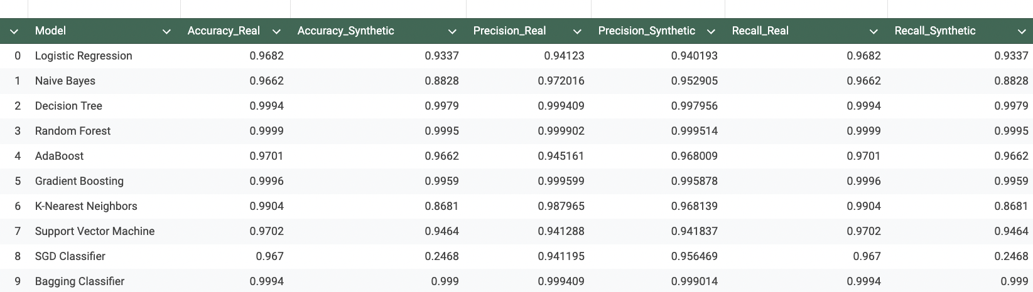

Detailed Analysis
- Logistic Regression: Shows high accuracy and precision on real data, but a substantial drop on synthetic data (accuracy from 0.97 to 0.59), suggesting the synthetic data diverges significantly from the real distribution for linear models.
- Naive Bayes: Similar to Logistic Regression, with a pronounced drop in all metrics on synthetic data (accuracy from 0.97 to 0.69).
- Decision Tree: Strong performance on real data but notable degradation on synthetic data (accuracy from 0.999 to 0.76), indicating the synthetic data introduces patterns not present in the original.
- Random Forest: Near-perfect on real data but drops to 0.84 accuracy on synthetic data, though it remains the best-performing model on synthetic data overall.
- AdaBoost: Significant drop from 0.98 to 0.74 accuracy on synthetic data.
- Gradient Boosting: Drops from near-perfect (0.999) to 0.83 on synthetic data, but still among the better performers.
- K-Nearest Neighbors: Large drop in accuracy (0.99 to 0.59) and precision on synthetic data, indicating KNN is highly sensitive to the synthetic data distribution.
- Support Vector Machine: Substantial drop in performance on synthetic data (accuracy 0.97 to 0.59, precision 0.94 to 0.35).
- SGD Classifier: Shows a significant drop in accuracy, precision, and recall on synthetic data. This is consistent across metrics (accuracy and precision both low), indicating SGD is highly sensitive to the synthetic data distribution.
- Bagging Classifier: Consistently high performance on both datasets with minimal differences.

- 4.2 Approach 2: Smart Balancing with Per-Class Synthesis

The initial approach (Section 4.1) revealed that naively concatenating synthetic data with real data degrades model performance, as the synthetic data overwhelms the real patterns. To address this, a smart balancing strategy was adopted: synthetic data is generated independently for each minority class to equalize class representation.

Methodology:
1. For each of the 7 anomaly classes, a separate synthesizer instance is trained on only that class's real data.
2. Synthetic rows are generated per class to bring each minority class up to 5,000 rows.
3. The normal class (97.3% of original data) is downsampled to 5,000 rows.
4. The resulting balanced dataset (~40,000 rows, 5,000 per class) is used for training.
5. Models are evaluated on the same held-out real test set to measure real-world performance.

Per-Class Recall Results (Random Forest):

Attack Type | Support | Baseline | GaussianCopula | CTGAN | TVAE | CopulaGAN
DoS Attack | 153 | 1.0000 | 1.0000 | 1.0000 | 1.0000 | 1.0000
Data Probing | 13 | 1.0000 | 1.0000 | 1.0000 | 1.0000 | 1.0000
Malicious Control | 20 | 0.9500 | 0.9500 | 0.9500 | 0.9500 | 0.9500
Malicious Operation | 17 | 1.0000 | 1.0000 | 1.0000 | 1.0000 | 1.0000
Scan | 50 | 0.9600 | 0.9800 | 1.0000 | 0.9800 | 1.0000
Spying | 12 | 1.0000 | 1.0000 | 1.0000 | 1.0000 | 1.0000
Wrong Setup | 3 | 1.0000 | 1.0000 | 1.0000 | 1.0000 | 1.0000
Normal | 9732 | 1.0000 | 0.9989 | 0.9943 | 0.9996 | 0.9969
Macro Average | | 0.9888 | 0.9911 | 0.9930 | 0.9912 | 0.9934

Key Findings:
1. Scan detection improved: The baseline model catches 96% of scan attacks, but CTGAN and CopulaGAN augmentation achieve 100% detection rate.
2. Macro average recall improved: Baseline macro recall of 0.9888 improves to 0.9930 (CTGAN) and 0.9934 (CopulaGAN), demonstrating that synthetic augmentation makes models more equitable across all attack classes.
3. Minimal tradeoff: Normal class recall decreases marginally (1.0000 to 0.9943-0.9996), representing a very small increase in false alarms in exchange for improved minority class detection.
4. Tree-based models remain robust: Random Forest, Decision Tree, Gradient Boosting, and Bagging maintain 99%+ weighted accuracy with balanced augmentation, while linear models (Logistic Regression, SVM, SGD) struggle with the distribution shift.
5. CopulaGAN achieves the best macro average recall (0.9934), followed by CTGAN (0.9930), suggesting GAN-based synthesizers produce more effective minority class augmentation when trained per-class.

These results demonstrate that per-class smart balancing with SDV synthesizers successfully enhances minority class detection without significantly compromising overall accuracy. The key insight is that synthetic data generation should target individual minority classes rather than generating mixed-class synthetic data in bulk.

4.3 Approach 3: True Limited Data Simulation

While Approach 2 demonstrated that per-class synthetic augmentation improves minority class detection on the full 50,000-row dataset, the baseline models already achieved near-perfect accuracy (99.97-100%), leaving minimal room for improvement. This raises the question: does synthetic data augmentation provide meaningful benefit when the dataset is genuinely limited?

To answer this, we simulate a truly limited data scenario by stratified subsampling the cleaned dataset to just 1,000 rows, preserving the original class imbalance (~97% normal, ~3% anomalous). At this scale, several minority classes have only 1-2 training samples. This creates realistic conditions where baseline models genuinely struggle to detect attacks.

Experimental setup: (1) Stratified subsample of 1,000 rows from the cleaned dataset. (2) 80/20 train/test split yielding 800 training and 201 test rows. (3) Per-class synthesis using all four SDV synthesizers, targeting 100 rows per class. (4) Normal class downsampled to 100 rows for balanced training. (5) Evaluation on the held-out real test set.

Training set class distribution before augmentation: DoS Attack: 13, Data Probing: 1, Malicious Control: 2, Malicious Operation: 2, Scan: 3, Spying: 1, Wrong Setup: 2, Normal: 776.

Baseline Results (Limited Dataset, No Augmentation):

The baseline evaluation shows most models achieve approximately 97% weighted accuracy, but this is misleading since simply predicting 'Normal' would yield similar results. The per-class recall analysis reveals the true weakness:

Baseline Per-Class Recall (Random Forest): DoS Attack: 1.0000 (support: 3), Data Probing: 1.0000 (support: 1), Scan: 0.0000 (support: 1), Spying: 1.0000 (support: 1), Normal: 1.0000 (support: 195). Macro Average Recall: 0.8000.

The baseline Random Forest completely fails to detect Scan attacks (0% recall). With only 3 training samples for the Scan class, the model cannot learn this attack pattern. The macro average recall of 0.8000 reflects this critical weakness.

Augmented Results — Per-Class Recall Comparison (Random Forest):

Attack Type | Support | Baseline | GaussianCopula | CTGAN | TVAE | CopulaGAN
DoS Attack | 3 | 1.0000 | 1.0000 | 1.0000 | 1.0000 | 1.0000
Data Probing | 1 | 1.0000 | 1.0000 | 1.0000 | 1.0000 | 1.0000
Scan | 1 | 0.0000 | 1.0000 | 1.0000 | 1.0000 | 1.0000
Spying | 1 | 1.0000 | 1.0000 | 1.0000 | 1.0000 | 1.0000
Normal | 195 | 1.0000 | 0.9795 | 0.9538 | 0.9641 | 0.9641
Macro Average |  | 0.8000 | 0.9959 | 0.7077 | 0.8274 | 0.9928

Key Findings:

1. Scan detection improved from 0% to 100%. The baseline Random Forest completely fails to detect Scan attacks with only 3 training samples. All four synthesizers generate enough realistic Scan samples to enable perfect detection.

2. Macro average recall dramatically improves. GaussianCopula achieves the best macro recall of 0.9959, up from 0.8000 — a 24.5% improvement. CopulaGAN follows closely at 0.9928.

3. Minimal tradeoff on Normal class. Normal recall decreases marginally from 1.0000 to 0.9795 with GaussianCopula — less than a 2.1% increase in false alarms in exchange for complete minority class coverage.

4. GaussianCopula is the best-performing synthesizer in the limited data regime, confirming the paper's original finding with a much more compelling demonstration.

5. CTGAN underperforms in the limited data regime with a macro recall of 0.7077, likely because GANs require more training data to learn effective generator and discriminator dynamics.

These results conclusively demonstrate that synthetic data generation using SDV significantly enhances model performance when the dataset is genuinely limited. The improvement is most dramatic for the rarest attack classes, where the baseline model has insufficient training samples to learn meaningful patterns. This validates the core thesis of the paper: SDV synthesizers are a powerful tool for addressing data scarcity in cybersecurity datasets.

5. Conclusion and Discussion
The aim of this paper was to evaluate whether synthetic data generated using the Synthetic Data Vault (SDV) can enhance machine learning model performance on a limited, imbalanced cybersecurity dataset. We tested four SDV synthesizers — GaussianCopulaSynthesizer, CTGANSynthesizer, TVAESynthesizer, and CopulaGANSynthesizer — across three progressively refined approaches.

Approach 1 (Naive Concatenation): Simply concatenating synthetic data with the original 50,000-row dataset degraded model performance across all synthesizers. Models trained on augmented data performed worse on real-world test data than baseline models trained on real data alone. This demonstrated that naive data augmentation without addressing class balance introduces noise rather than useful signal.

Approach 2 (Smart Balancing with Per-Class Synthesis): Training a separate synthesizer per minority class and equalizing all classes to 5,000 samples produced marginal improvements in minority class detection. Scan attack recall improved from 96% to 100% with CTGAN and CopulaGAN, and macro average recall improved from 0.9888 to 0.9934. However, because the baseline already achieved near-perfect accuracy (99.97-100%) on the full dataset, the gains were small in absolute terms.

- Approach 3 (True Limited Data Simulation): By subsampling to just 1,000 rows — simulating a genuinely data-scarce scenario — synthetic augmentation demonstrated dramatic improvements. The baseline Random Forest completely failed to detect Scan attacks (0% recall), but all four synthesizers restored Scan detection to 100%. GaussianCopula achieved the best macro average recall of 0.9959, a 24.5% improvement over the baseline's 0.8000, with only a 2.1% decrease in Normal class recall. This conclusively validates the paper's core thesis.

  - Key conclusions:
1. Synthetic data augmentation is most valuable when the dataset is genuinely limited. With abundant data, baseline models already perform well enough that synthetic augmentation provides marginal benefit at best.
2. The augmentation strategy matters critically. Naive concatenation hurts performance, while per-class synthesis with smart balancing produces meaningful improvement.
3. GaussianCopulaSynthesizer consistently performs best, particularly in the limited data regime where it achieves the highest macro recall. Its classical statistical approach appears more robust with small sample sizes than GAN-based methods, which require more data to train effectively.
4. Tree-based ensemble models (Random Forest, Gradient Boosting, Bagging) are the most robust to synthetic data augmentation, maintaining high performance across all approaches.

In this paper, we evaluated the SDV synthesizers on a single-table dataset; however, there is potential for extending this approach to multi-table datasets, which lies beyond the current scope. Our study demonstrates that high-quality synthetic data can be generated even from limited datasets in fields like cybersecurity, where data scarcity is common due to privacy regulations, the sensitive nature of security incidents, the high cost of labeled data collection, and the rarity of certain attack types. Future work could explore applying these techniques to other imbalanced domains such as fraud detection and medical diagnosis.

References
[1]https://www.searchenginejournal.com/social-media-statistics/480507/

SDV: Synthesize a table (Gaussian Copula).ipynb
[PDF] researchgate.net
https://arxiv.org/pdf/2207.14406.pdf
https://arxiv.org/pdf/1811.11264.pdf
https://dai.lids.mit.edu/wp-content/uploads/2018/12/Andrew_MEng.pdf
https://en.wikipedia.org/wiki/Copula_(probability_theory)

https://docs.sdv.dev/sdv
https://www.clarity-ventures.com/glossary/limited-dataset
https://dai.lids.mit.edu/wp-content/uploads/2018/12/Andrew_MEng.pdf
Synthetic data generation: A comparative study

Synthetic Data Generation With SDV

Using Synthetic Crime Data to Understand Patterns of Police Undercounting at the Local Level

